Patient information and statement of consent

Port-a-Cath

Dear Patient,

Your disease (………………………………………………………………………) requires long-term venous medication. This treatment can damage the vein wall, therefore we consider it expedient to create a „gate” in the body through which the treatment can be provided in a more secure and convenient way for you.
Please read the information below and approve with your signature that you wish to receive the recommended procedure, i.e. the implantation of the venous port.

………………………….
Treating physician’s signature

Information on „what you need to know about the ports (Port-a-Cath)”
The medical port or Port-a-Cath is a cannula that is surgically implanted under the skin. Its purpose is to avoid the damage of the veins, or relieve the venous system damaged by multiple treatments. Its advantage is that, since it is a closed system, there is no increased risk of infection in the periods between outpatient treatments.
Port implantation is recommended for all patients (regardless of general condition) who require infusion therapy.
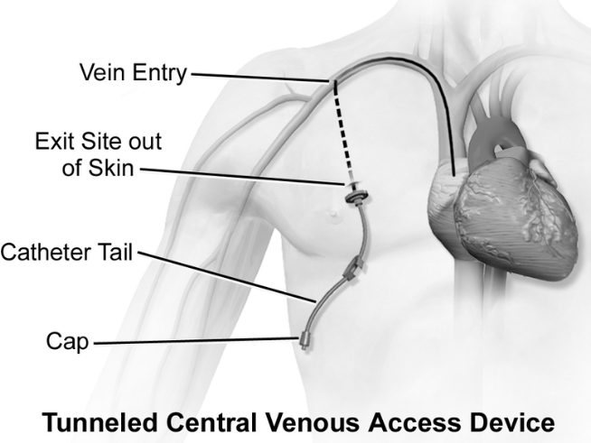

The structure and function of the Port-a-Cath
The phrase „Port-a-Cath” is composed from its two main components: „port (portal)” and „cath (catheter)”. The top of the port-part is covered by a self-sealing silicone layer (septum) and its body is made of plastic, stainless steel or titanium. A catheter is connected to this which is a flexible tube (silicone or polyurethane).
When it is used, a needle of a special connector is inserted through the silicone top of the implanted port (through the skin) through which the required liquid substance can be dispensed. This substance can be medicine, other fluid (parenteral nutrition, contrast agent) or blood, but even a blood sample can be taken this way. Puncturing the skin may initially be sensitive at the port, but this will improve over time.
The substance administered this way first enters the port chamber and then through the catheter into the vein.
The closed system does not require any special care from the patient.
It is advisable to keep the surface of the skin clean and, for men, to shave the chest hair to ensure fixation and sterility.
When inserting and removing the needle, it is advisable to choose clothing that provides easy access to the chest and, where appropriate, the arm (depending on where the port is implanted) – it should not be slinky, the sleeves should not be tight, (it should be a) top with button or zipper. The port is not affected by the usual daily activities such as bathing or light movement.
Saline and Heparin has to be infused periodically into the port for cleaning and to prevent clot formation (if the patient does not have blood clotting disorder or hypersensitivity). This is also transferred through the port chamber, just like the administration of the medicine. This procedure is usually performed at the end of the treatments or, if the port is not used, every four weeks.

Implantation and removal of the Port-a-Cath

Implantation of a Port-a-Cath involves a brief surgical procedure with a local anaesthesia. The catheter is surgically inserted into one of the veins (usually into the subclavian vein), and then the port is placed under the skin (subcutaneous) usually on the chest wall. After the procedure the inserted port shows as a small bump underneath the skin.
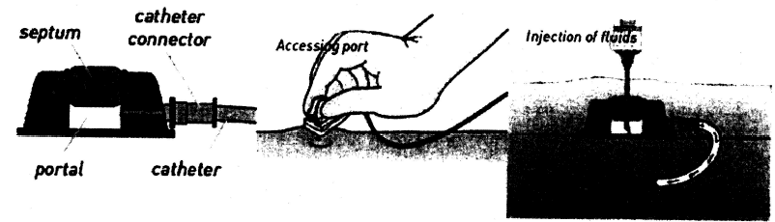
At the end of the therapy, the removal is also surgically performed. The physician performing the implantation will give you a so called identification (ID) card of the implantation and your port that you should carry with you. This card can provide information about the fact of the implantation and the type of the port.

Care of the Port-a-Cath

The long-term operation of the port requires careful cooperation between you and the care team. As you might have read in the general description, if the port is not punctured, no long-term medication is delivered through it; it does not require special care. During this time, you just need to be careful to keep your skin properly clean over the port.
At the time of puncturing, the professional can be greatly assisted by a properly selected clothing (see puncturing the port).
It is advisable for men to shave the chest hair, because it is beneficial in terms of fixing as well as of hygiene.
If you still see a small wound above the canal after the puncture, you can clean it 1-2 times a day with a skin disinfectant. If you experience swelling, pain or redness around the port (especially during therapy), please contact your physician immediately.
If you experience any abnormalities around the port during therapy, or if you experience chills, fever, and, in addition to the side effects that are told by your physician other sickness occurs (such as chest pain), please do not hesitate to contact your healthcare provider immediately.
The adhesive plaster may be exposed to a few drops of water e.g. when showering, but due to direct water jet or in case of bathing it may soak in the water and bacteria and fungi can easily multiply in a humid, warm environment. If the adhesive plaster is damaged even with the appropriate precautions, it must be covered sterile again as soon as possible.

Alternative to the implantation of the venous port:
- a vein should be provided occasionally (occasionally a new peripheral vascular cannula should be inserted, but this will cause the veins to “slowly run out”)
- securing the central vein can also be a temporary solution (the regular central venous catheter can remain in the body for up to 2 weeks under continuous hospital control, thus, with rare exception, the patient cannot go home with it)
- peripherally inserted central catheter (PICC line) can be used for long-term venous treatment for months, but the risk of infection and the need for care of the catheter is much greater.

Frequently asked questions:
1. How to care of the implanted port?
- If the port has been connected to infusion, the needle is taped and secured in place. This time you can do your daily routine, taking care of not to move the needle. If you notice anything unusual (bruising, redness, pain, unusual malaise, fever, chills) please report the functional disorder of the pump to your physician or nurse immediately.
- If there is no infusion given into the port, you have nothing to do with it, as it is a closed system.

2. How long can the port stay in place?
- If your implanted port is properly inserted and cared of throughout the whole therapy, it can stay in place for years.
3. What activities should I avoid while the implanted port in place?
- Hard physical work.
4. Can I have an MRI with my implanted port?
- Yes, the port is usually made of a material that may undergo an MRI scan. For the sake of safety, please also ask your physician prior to receiving an MRI.
5. Can I go through a security gate with my implanted port?
- The port is usually made of a material that will not detected by the metal detector. Nevertheless, you may want to carry the identification card of the port with you.
6. How should I sleep with my implanted port?
- The inserted port does not affect sleep.
7. How should I take a bath with my implanted port?
- If there is no medication delivered, you can take a bath and go to the beach.
- If medication is delivered through the pump, you should avoid bathing, going to the beach, swimming during therapy. It is more advisable to take a shower or wash yourself. The bandage may be exposed to water but it can soak from plenty of water.

As with any procedure, this procedure may also have unpleasant effects and complications:
Puncturing the skin and the subcutaneous tissue is painful.
The following may occur rarely: artery puncture, nerve injury, haematoma, local haemorrhage, pain, and swelling.
PTX (pneumothorax) may also occur, which is extremely rarely surgically treated.
During the procedure you need to lie in the so-called Trendelenburg position (with a head-down tilt of 10-15 degrees, limbs higher), with head turned to one side.
The condition of the skin has to be monitored. In case of redness or discharge, you need to consult the doctor immediately.
Even with the most careful management of the implantation of the port, it may facilitate the entry of pathogens into the body. Symptoms of this very serious complication are:
shivering, chills, fever, weakness, rapid heartbeat, blood pressure fluctuations. If these symptoms occur, it is important to see a physician immediately!

Name of the patient:
Date of birth:
Social security number (TAJ):

I have read and understand the above information and give my consent to perform the implantation of the venous port.

Budapest, …………………………

……………………………
Patient’s signature

I do not give my consent to perform the implantation of the venous port.

Budapest, …………………………

……………………………
Patient’s signature

