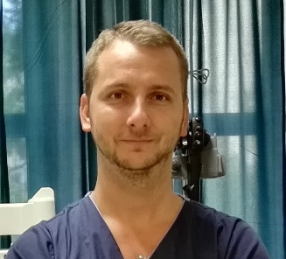

Adam Tarpay, MD, PharmD
Internist
Gastroenterologist

Workplace:
National Institute of Oncology
Department of Interventional Gastroenterology
Phone: +312248600/3671
Email: adamtarpay@gmail.com

Qualification
- 1996. High-school graduation: Budapest, Kossuth Zsuzsa Eü. Szki. És Gimnázium
- 2006. Semmelweis University, Faculty of Medical School
- 2006. Semmelweis University, Faculty of Pharmacy

Spoken languages
- hungarian
- english
- german (basic level)

Specialties
- 2012. internist
- 2014. gastroenterologist
- 2015. endoscopic ultrasound

Workplaces
- 2009- National Institute of Oncology

Fellowship of Scientific Organisations
- Hungarian Society of Gastroenterology
- ASGE

Publications

- Alternatives for the intensive follow-up after curative resection of colorectal cancer. Potential novel biomarkers for the recommendations.Orosz E, Ember I, Gombos K, Tóth L, Tarpay Á, Pap Á, Ottó S. Pathol Oncol Res. 2013 Oct;19(4):619-29.
- Need for developing a new strategy in the follow-up of colorectal cancer patients; the micro RNAs (miRNAs), as potential new biomarkers of early detection. Orosz E, Ember I, Gombos K, Tóth L, Vámosi Nagy I, Tarpay A, Pap A, Ottó S. Magy Onkol. 2012 May;56(2):93-102.
- A double immunochemical method for detecting faecal haemoglobin and albumin in rectal screening. Tarpay A, Szabadosné Németh M, Orosz E, Kásler M, Burai M, Pap A, Ottó S. Magy Onkol. 2011 Nov;55(4):268-73.
- Laparoscoppal végzett subtotalis gyomorresectio Roux-en-Y szerinti rekonstrukcióval, antralis gyomoradenocarcinoma miatt.
Sztipits T, Mészáros P, Dubóczki Z, Tarpay Á, Mersich T.
Magy Seb. 2015 Dec;68(6):235-8. doi: 10.1556/1046.68.2015.6.4. Hungarian.

