Curriculum Vitae

 | 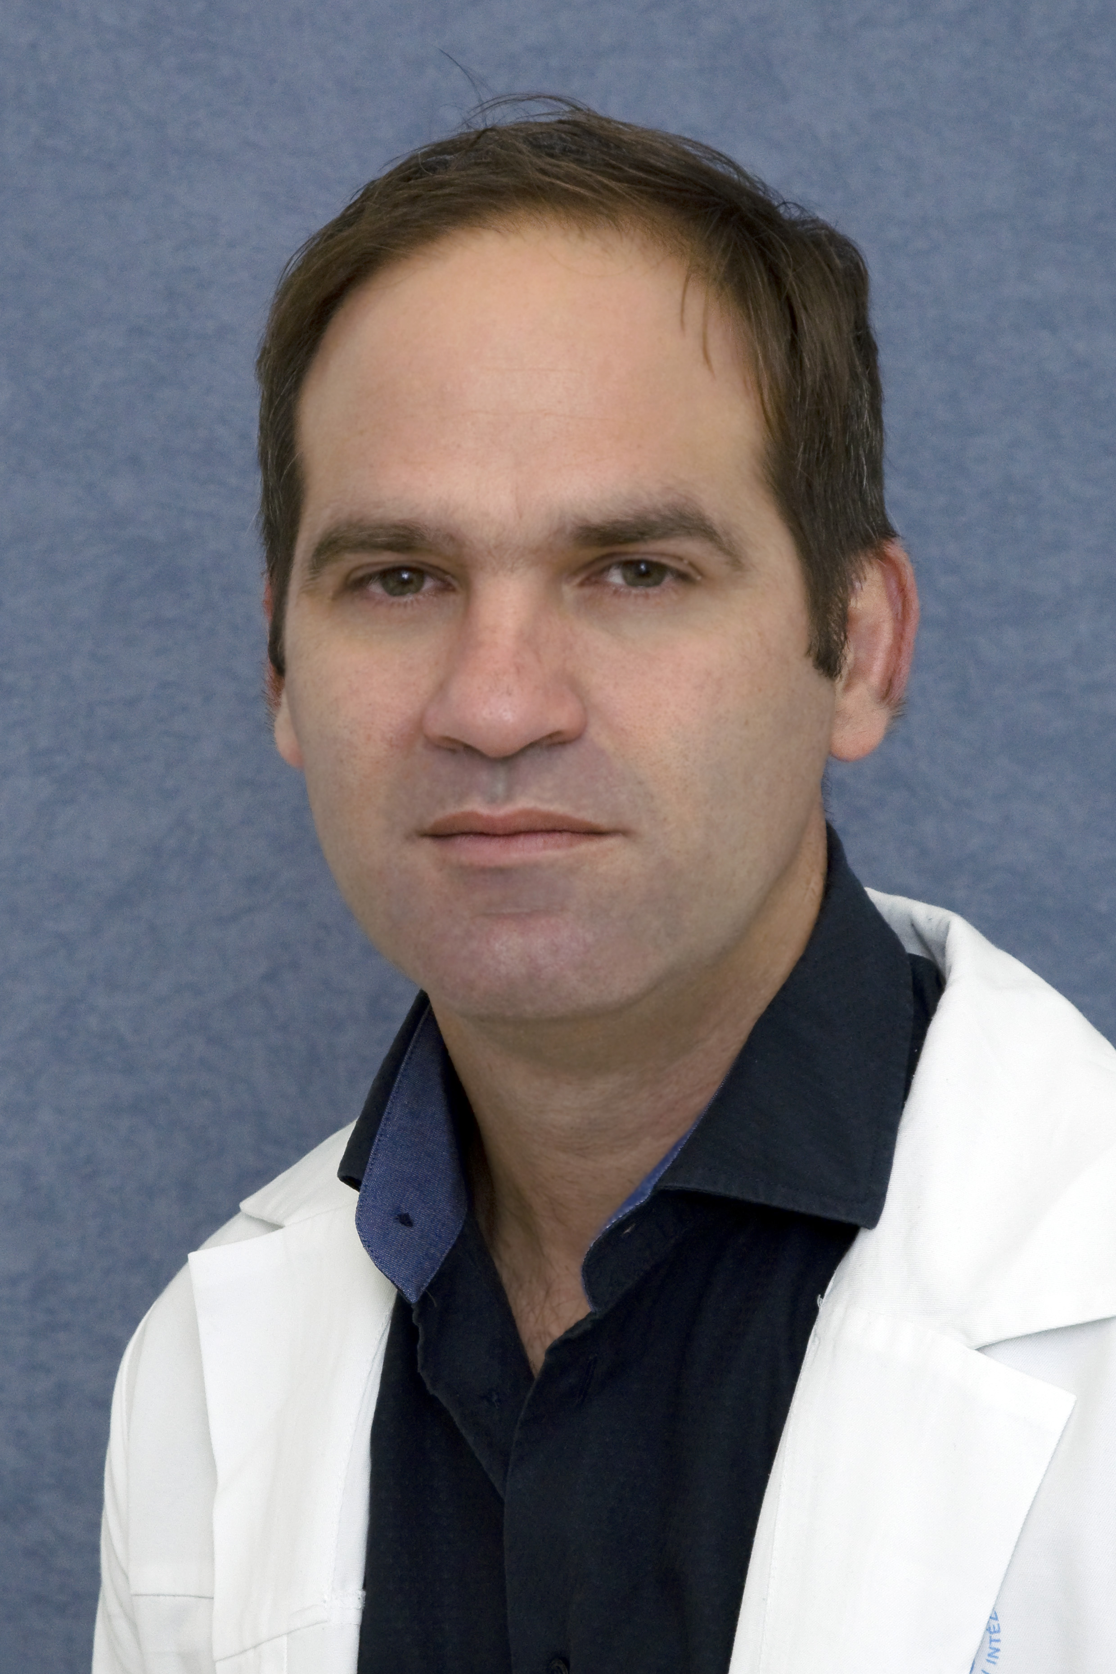
First name / Last name | Dr. Péter Mészáros
Address | H-1037 Budapest, Farkastorki út 26.
Telephone | 0036-70-2400175
Fax(es) | 0036-(1)-224-8620
E-mail | dusnok.peter@gmail.com
Nationality | Hungarian
Date of birth | September 29, 1974.
Registration number | 59906
Work experience
Duration | 2000-2007 Mar | junior doctor  Polyclinic of the Hospitaller Brothers of St. John of God in Budapest  Department of Surgery
 | March 28, 2007-Dec 31, 2013 | general surgeon  Polyclinic of the Hospitaller Brothers of St. John of God in Budapest  Department of Surgery
 | Jan 01, 2013 | consultant surgeon  National Institute of Oncology, Center of Cancer Surgery, Budapest
Main responsibilities and range of duties | surgical care of inpatients, surgical care of outpatients, acute surgical care on call,  laparoscopic colorectal surgery, hepato-bilio-pancreatic surgery, upper GI surgery,  clinical-pharmacological studies
Name and address of the employer: | National Institute of Oncology, Center of Cancer Surgery,  H-1122 Budapest Ráth György str.7-9.
Qualification
Duration | 1989-1993
Qualification | High-school degree
Name and type of the Institution | High-school of the Piarist Brothers, Kecskemét
Duration | 1994-2000
Qualification | General physician
Name and type of the Institution | Medical University of Pécs, General Faculty of Medicine
Duration | 2000-2007
Qualification | General surgeon
Name and type of the Institution | Semmelweis University
Personal skills and competences
Mother tongue | Hungarian
Other languages | English
Training | DEOEC Klinikai Farmakológiai Tanszék által szervezett GCP tanfolyam:  “GCP. A helyes klinikai gyakorlatok irányelvei ANNO 2009”  Miskolc, 2009. március 13-14.  ESO-ESSO Masterclass in Colorectal Cancer Surgery  23-28 February 2013. Ljubljana, Slovenia  UEGF Professional Trainee Course on "Colo-rectal cancer - from prevention to palliation",  held at the NCT-DKFZ Heidelberg, Germany 2011  Fundamntals of effectiv colonoscopy: hands-on course, Hamburg, Germany 2010.
Recent clinical trial experience | Antibiotic treatment in DF patient phase III. 2005/2006, sub-investigator  Antibiotic treatment in DF patient phase III. 2006/2008, sub-investigator  Antibiotic treatment in DF patient phase III. 2007/2009, sub-investigator  Locally used PDGF in DF patients phase III. 2012/2013 sub investigator  SOAP trial 2017/2018 Principal investigator
Professional skills and competences | surgical treatment of gastroduodenal and colon diseases with or without tumor,  anorectal surgery, advanced laparoscopic surgery (colorectal disease, pancreato-biliary surgery)
Related Professional Membership | Hungarian Society for Surgery

18 FEB 2019 Dr. Péter Mészáros

