BERNADETT TALLÓSY M.D.
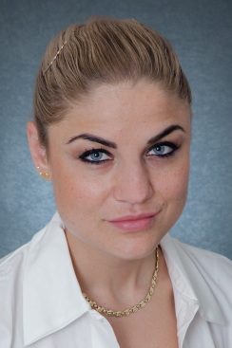
Phone: +36 (30) 314-93-26
E-mail: tallosy.bernadett@oncol.hu

DIPLOMA
Semmelweis University, Faculty of Medicine, Budapest, M.D. (2014)

SPOKEN LANGUAGES
Croatian (advanced level)
English (medium level)

POSTGRADUATE EDUCATIONS
Thoracic surgery resident since 2014.

WORK EXPERIENCE
2018- National Institute of Oncology Thoracic surgery resident: Performing operations of general thoracic surgery: minimal-invasive (VATS) and open procedures for lung cancer, mediastinal tumours, inflammatory diseases of the chest and pneumothorax
2019- Lung transplantation – lung procurement coordinator
2014-2018 Bajcsy-Zsilinszky Hospital General and thoracic surgery resident: laparoscopy, and open abdominal procedures, VATS and open procedures, doctor of the VIP department

EDUCATION ACTIVITIES
2018 – Gradual education: Thoracic Surgery seminars for 5th year medical students

POSTGRADUATE COURSES, SCHOLARSHIPS
2013 – 2014 Scolarship of the Hungarian Republic
2012 - Surgery: Frankfurt Uniklinik, Department of Cardiothoracic Surgery

AWARDS
2012. I prize Pulmonology academic competition
2012. I prize, " Phosphoinositide-sensitivity in the endocytosis of G-protein coupled receptors"
Korányi Frigyes Scientific Forum, Budapest
2010. II prize, Medical biochemistry academic competition
2010. III prize, Physiology academic competition

MEMBERSHIPS
Member of the Hungarian Society for Transplantation
Member of the Hungarian Society of Thoracic Surgeons
Member of the European Society of Thoracic Surgeons (ESTS)
Member of the Hungarian Society of Pulmonologists

Date: January 2019.

