ÁRON KRISTÓF GHIMESSY M.D.
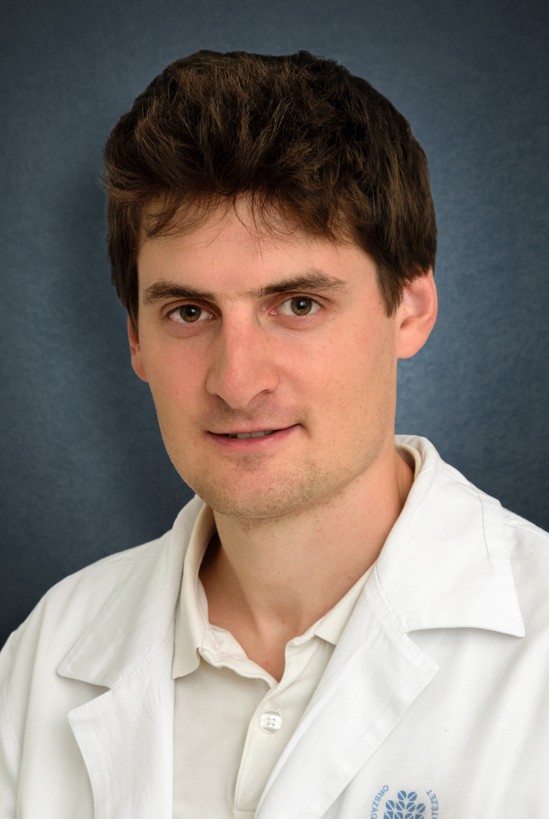
Phone: +36 (20) 670-11-26
E-mail: ghimessy@oncol.hu

DIPLOMA
Semmelweis University, Faculty of Medicine, Budapest, M.D. (2014)

SPOKEN LANGUAGES
English (advanced level, Euro C1 State Exam)
German (medium level)

POSTGRADUATE EDUCATIONS
Thoracic surgery resident since 2014.

WORK EXPERIENCE
2014 – Thoracic surgery resident: Performing operations of general thoracic surgery: minimal-invasive (VATS) and open procedures for lung cancer, mediastinal tumours, inflammatory diseases of the chest and pneumothorax. Lung transplantation – lung procurement. In the future, I plan to implement robotic surgery in the Hungarian Thoracic Surgery practice.

2011 – 2014 – National Ambulance Service (Emergency care assistant, Paramedic)

PUBLICATIONS
I. Publications in English peer-viewed journals:

1. Tolnay, E.*, Ghimessy, Á.*, Juhász, E., Sztancsik, Z., Losonczy, G., Dombi, P., Vennes, Z., Helf, L., Csada, E., Sárosi, V. The efficacy and safety of bevacizumab in addition to platinum based chemotherapy for the first line treatment of patients with advanced nonsquamous non small cell lung cancer: Final results of AVALANCHE, an observational cohort study. Oncology Letters 17, no. 2 (2019): 1750-1760. https://doi.org/10.3892/ol.2018.9766
*Megosztott első szerzős publikáció

2. Madurka I, Elek J, Schönauer N, Bartók T, Kormosói-Tóth K, Zöllei É, Ghimessy Á, Lang G, Klepetko W, Rényi-Vámos F. Urgent Lung Transplantation in Severe Acute Respiratory Failure Based on Rapidly Progressive Interstitial Lung Disease: A Case Report. Transplant Proc. 2017 Sep;49(7):1544-1548. doi: 10.1016/j.transproceed. 2017.06.020. PMID: 28838437

3. Madurka I, Elek J, Schönauer N, Bartók T, Kormosói-Tóth K, Radeczky P, Gieszer B, Ghimessy Á, Lang G, Klepetko W, Rényi-Vámos F. Early Postoperative Problems After Lung Transplantation: First-Year Experiences in Light of the Newly Established National Hungarian Lung Transplantation Program. Transplant Proc. 2017 Sep;49(7):1538-1543. doi: 10.1016/j.transproceed. 2017.06.018. PMID: 28838436

4. Rényi-Vámos F, Radeczky P, Gieszer B, Ghimessy Á, Czebe K, Török K, Döme B, Elek J, Klepetko W, Lang G, Madurka I. Launching the Hungarian Lung Transplantation Program. Transplant Proc. 2017 Sep;49(7):1535-1537. doi: 10.1016/j.transproceed. 2017.06.017. PMID: 28838435

5. Földes K, Piros L, Toronyi E, Wagner L, Chmel R, Török S, Nagy K, Ghimessy Á, Brinzanek D, Pőcze B, Langer RM, Gerő L. Examination of carbohydrate metabolism parameters after simultaneous pancreas-kidney transplantation. Transplant Proc. 2013;45(10):3698-702. doi: 10.1016/j.transproceed. 2013.10.006.

II. Publications in Hungarian journals:

- Gieszer B, Radeczky P, Ghimessy Á, Farkas A, Csende K, Bogyó L, Fazekas L, Kovács N, Madurka I, Kocsis Á, Agócs L, Török K, Bartók T, Dancs T, Schönauer N, Tóth K, Szabó J, Eszes N, Bohács A, Czebe K, Csiszér E, Mihály S, Kovács L, Müller V, Elek J, Rényi-Vámos F, Lang Gy. The start of the Hungarian lung transplantation program and the first results. Orv Hetil 2018.Nov; 159(46): 1859-1868.

- Farkas A, Kocsis Á, Andi J, Sinkovics I, Agocs L, Meszaros L, Török K, Bogyó L, Radecky P, Ghimessy Á, Gieszer B, Lang Gy, Rényi-Vámos F. Minimally invasive resection of nonpalpable pulmonary nodules after wire- and isotope-guided localization. Orv Hetil. 2018 Aug;159(34):1399-1404. doi: 10.1556/650.2018.31148.

EDUCATION ACTIVITIES
2018 – Education Officer
2016 – Organisation of postgraduate VAST courses
2014 – Gradual education: Thoracic Surgery seminars for 5th year medical students

POSTGRADUATE COURSES, SCHOLARSHIPS
2018 - Robotic Thoracic Surgery: Moffit Cancer Center, Tampa, Florida, USA and University of New York, Langone Hospital, NY, USA
(Sólyom László scholarship)
2014 - Paediatrics: University of California, Davis School of Medicine, Sacramento
(UC Davis Scholarship)
2013 - Gynaecology: Vivantes Klinikum Neuköln, Berlin
(Erasmus +)
2013 - Pulmonology, thoracic surgery: Klinik für Innere Medizin – Pneumologie und infektologie, Vivantes Klinikum Neuköln, Berlin
(Erasmus +)
2012 - Neurosurgery: Helsinki University, Department of Neurosurgery
(Erasmus)
2012 - Thoracic surgery: Helsinki University, Department of Cardiothoracic Surgery
(Erasmus)

AWARDS
2017. Prize for the best young presenter: DCD donation in lung transplantation
Annual Meeting, Hungarian Transplantation Society
2015. III. best presentation: Lung transplantation after haemopoietic stem cell transplantation
Young Surgeons Meeting, Hungarian Surgery Society
2015. III. best presentation: Lung transplantation after haemopoietic stem cell transplantation
Young pulmonologists forum, Hungarian Respiratory Society
2014. `Ulmann Imre` prize for the best presentation: Tolerance induction: Living donor lung transplantation after allogenic stem cell transplantation
XIV. Annual Meeting, Hungarian Transplantation Society
2013. I. prize "Surgery" category, “Metabolic changes after simultaneous pancreas and kidney transplantation”
8. YES Meeting (Porto, Portugal)
2013. II. best presentation prize, " Metabolic changes after simultaneous pancreas and kidney transplantation and the future of treatment in type I. diabetes"
IV. International Medical Student Research Congress (Istanbul, Turkey)
2013. II. prize, " Metabolic changes after simultaneous pancreas and kidney transplantation "
Korányi Frigyes Scientific Forum, Budapest
2013. III. prize, " Metabolic changes after simultaneous pancreas and kidney transplantation "
National Scientific Student Conference, Szeged.
2012. I. prize, " Metabolic changes after simultaneous pancreas and kidney transplantation "
Scientific Student Conference, Semmelweis University, Budapest

MEMBERSHIPS
Member of the Hungarian Society for Transplantation
Member of the Hungarian Society of Thoracic Surgeons
Member of the European Society of Thoracic Surgeons (ESTS)

