LEVENTE BOGYÓ M.D.
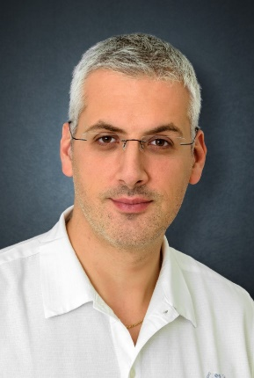
Phone: +36 (20) 670 1199
E-mail: levente.bogyo.dr@gmail.com

DIPLOMA
University of Medicine, Marosvásárhely, M.D. (2004)

MEDICAL SPECIALTIES
General Surgery (2011)
Emergency Medicine (2013)
Thoracic Surgery (2015)

SPOKEN LANGUAGES
english (medium level).
romanian (advanced level)

POSTGRADUATE EDUCATIONS
2018. Advanced Uniportal VATS Course, Shanghai, China
2015. Experimental Workshop on Uniportal VATS, Coruna, Spain
2015. ESTS School of Thoracic Surgery, Antalya, Turkey

WORK EXPERIENCE
2016– Thoracic Surgeon, Péterfy Sándor Hospital Trauma Center, Budapest.
2015– Thoracic Surgeon, National Institute of Oncology, Department of General and Thoracic Surgery, Budapest.
2015– Thoracic Surgeon, Semmelweis Medical University Thoracic Surgery Clinic, Budapest.
2015– EM specialist, Tatabánya Hospital, Emergency Department Tatabánya.
2013-2014 EM specialist, Zalaegerszeg Hospital, Emergency Department, Zalaegerszeg.
2011- 2014 General Surgeon, Kaposi Mór Hospital, Department of General, Thoracic and Vascular Surgery

CLINICAL INTERESTS
As mainly thoracic surgeon my practice covers the field of minimal invasive and open thoracic surgery. My special interest in this field focuses on lung transplantation and minimal invasive lung surgery.
Related to speciality in emergency medicine I’m also interested in the postoperative care of critically ill patients.

EDUCATION ACTIVITIES
2015 - Semmelweis University, Gradual education: Thoracic Surgery Seminars for 5th year medical students

PUBLICATIONS

- The start of the Hungarian lung transplantation program and the first results; Gieszer B, Radeczky P, Ghimessy Á, Farkas A, Csende K, Bogyó L, Fazekas L, Kovács N, Madurka I, Kocsis Á, Agócs L, Török K, Bartók T, Dancs T, Schönauer N, Tóth K, Szabó J, Eszes N, Bohács A, Czebe K, Csiszér E, Mihály S, Kovács L, Müller V, Elek J, Rényi-Vámos F, Lang G.; Orv Hetil. 2018 Nov;159(46):1859-1868.

- Minimally invasive resection of nonpalpable pulmonary nodules after wire- and isotope-guided localization.;Farkas A, Kocsis Á, Andi J, Sinkovics I, Agócs L, Mészáros L, Török K, Bogyó L, Radecky P, Ghimessy Á, Gieszer B, Lang G, Rényi-Vámos F.; Orv Hetil. 2018 Aug;159(34):1399-1404.

- Simultaneous treatment of bilateral pneumothorax with videothoracoscopic surgery (VATS).; Balogh G, Almuhtadi K, Ifj Balogh G, Patak K, Zádori P, Bogyó L, Tóth L.; Magy Seb. 2008 Jun;61(3):125-7.

AWARDS
2012. Most innovative application award – Silicone implant for radiotherapy of rectum cancer, South Transdanubian Regional Innovation Agency, Focusing on People announcement;

MEMBERSHIPS
Member of the Hungarian Society for Transplantation
Member of the Hungarian Society of Thoracic Surgeons
Member of the Hungarian Society of. General Surgeons
Member of Hungarian Society of Pulmonology
Member of Hungarian Lung Transplantation Program
Member of European Society of Thoracic Surgeons
Member of the Hungarian Resuscitation Council
Member of the Hungarian Society of Emergency Medicine

